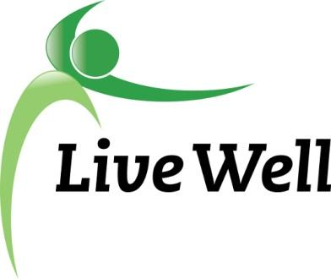**AGENDA**

**Healthy Food for All Work Group**

Virtual Meeting via Google Hangouts: meet.google.com/ccu-vhvx-heb

**2:00pm – 3:30pm, Thursday, October 28th, 2021.**

|  |  |  |
| --- | --- | --- |
| **Agenda items** | **Notes** | **Action Items** |
| **Introductions** | 1. Welcome everyone! Introductions, Accomplishments, and Ice Breaker: Happy Halloween! Do you have any plans/costumes? | Jessica Cooney, Susan Farley, Michele Dillon (last meeting), Kate LaRosh, Khiana Harris (Library Intern), Emily Lysen, Michaela Cantrell, Frankie Haynes, Laura McCulloch , Phone number  Congratulations to Susan on retirement! |
| **Announcements** | 1. LiveWell Douglas County Annual Celebration - December 3rd, 2021 at 10am. 2. Award Nominations 3. HFFA Vision Statement - [HBE Example](https://docs.google.com/document/d/1pGVBg1-zL85SnOEtHHbseG6cALjgnI-l/edit?usp=sharing&ouid=104924224549931881190&rtpof=true&sd=true) | Ideas: Farmers Market & Cottins, SNAP Ed., Laura, K-State, health department  Goals- growing & local opportunities, education about growing food (i.e. land access, increase # of people growing their own food), Check with food policy council for more collaboration  Simply produce- idea - UPC like a coupon, at a set amount they would scan when asked “would you like to donate?”  Next Meeting - December 9th combined November & December Meeting , Morning Time around 10am (?)  Pedestrian and transit survey: https://lawrenceks.org/listens/surveys/ |
| **Sharing of Resources/ Community Needs** |  |  |
| **HFFA Leadership Transition** | 1. Chair Elect! Apply for it! |  |
| **On-Going Projects** |  |  |
| **Adjourned** | 1. TBD |  |

Template for vision statement

Mission Template:

The Mission of the

workgroup is to __________(do what).

for _______ (whom)

so they can _______ (what)

To achieve our mission, we will….(list community/Pathway goals)